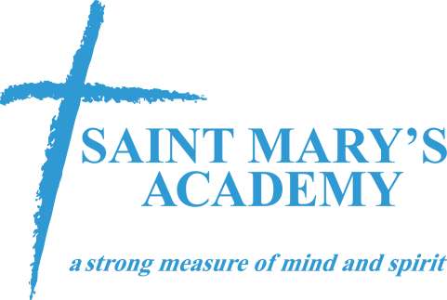
Zero Tolerance Policy
Academic Year:____________

St. Mary’s Athletic Association has adopted a ZERO TOLERANCE POLICY. This policy applies to all coaches, players, parents and other supporters. Abusive and obscene language, violent play, violent conduct, fighting and other behavior (including but not limited to sarcasm, taunting, etc.) deemed detrimental to the game between the above mentioned groups will not be tolerated.
It is the responsibility of the Coaches to provide Referee support and spectator control. This policy will apply to all times prior to, during and after practices and games at the soccer field and its immediate surrounding areas.

PARENTS / SPECTATORS:

NO PARENT OR OTHER SPECTATOR SHALL ADDRESS THE REFEREE AT ANY TIME !!!

Parents/other supporters shall remain in the area designated for spectators until after the game concludes. Parents /other supporters shall allow all coaching to be done so by the coach to eliminate confusion to the players.
This includes but is not limited to:
- No spectators making derogatory comments to players of either team, toward coaches or officials.
- No disputing calls during or after the game
- No remarks to the referee to watch certain players or attend to rough play
- No yelling at the referee, EVER, including any criticism, sarcasm, harassment, intimidation or feedback of any kind before, during or after the game.
The only allowable exceptions to the above are:
• Responding to a referee who has initiated a conversation with a parent or spectator.
• Pointing out emergency or safety issues.

PLAYERS:

Communications between players, coaches, spectators and referees shall remain sportsmanlike and respectful. Any infraction of this may result in suspension of play for an amount of time to be determined by the SMAA board.

COACHES :

It is the responsibility of all Coaches to maintain the highest standards of conduct for themselves, their players and supporters in all matches. Failure to do so undermines the Referee's authority and the integrity of the game resulting in a hostile environment for players, the referee, coaches, assistant coaches and spectators.

Coaches are reminded to adhere to the St. Mary’s Code of Conduct in addition to this policy.

Coaches are not to address the Referee during the game except for:
During the game:
• Responding to a referee who has initiated a conversation with a parent or spectator.
• Pointing out emergency or safety issues.
• Making substitutions,
• Asking the referee to repeat a call.
• Asking for the time remaining in the half.
Before the game. at half-time or after the game:
- A Coach or Assistant Coach can ask a referee to explain a law or foul in a respectful and constructive way, remembering that the call may remain the same.
- Polite and friendly concern can be exchanged with the referee. Absolutely no sarcasm, harassment or intimidation is allowed.
REFEREES:

It is the responsibility of the Referees to maintain the highest level of professionalism at all times. Answer questions posed to them by a Coach as allowed per the above guidelines in a prompt and courteous manner. Maintain their integrity and independence by not being influenced by acquaintances or by the Coaches or Assistant Coaches.
Athletes Name (print): _____________________
Athletes Name (sign): _____________________

Parents Name (print): _____________________
Parents Name (sign): _____________________

Coaches please sign below:

Coach Name (print): _____________________
Coach Name (sign): _____________________

Date:__________________

